# Load Test Detail

**Jmeter Script Result of the REST service /list**

**Case 1:**

* Thread Group: 1
* No of records in task table: 1022
* Loop Count:1

**Summary Report:**



**Graph Result:**

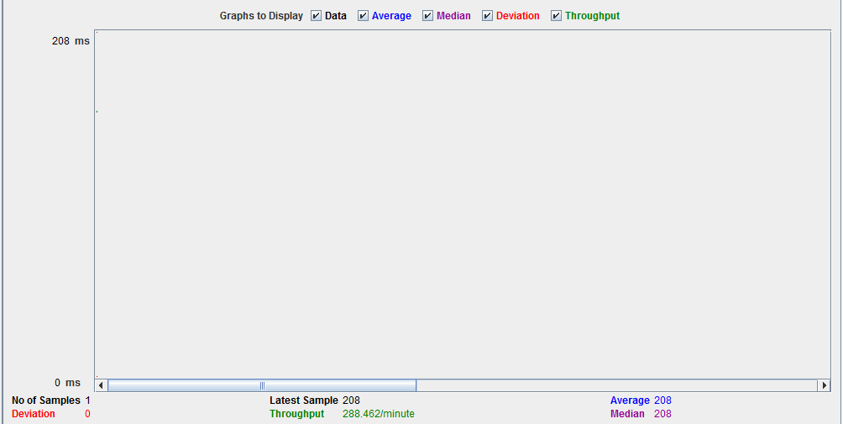

**Result:**

If there are approximately 1000 records in DB and only 1 user is sending request to show list from task table then that request is Passed and it tool 0.208 seconds to get the response of the api with throughput of 4.8/sec and 0% error rate.

**Case 2:**

* Thread Group: 1000 users
* Ramp Up: 1 second
* Loop Count: 1
* No of records in task table: 1022

**Summary Report:**



**Graph Result:**

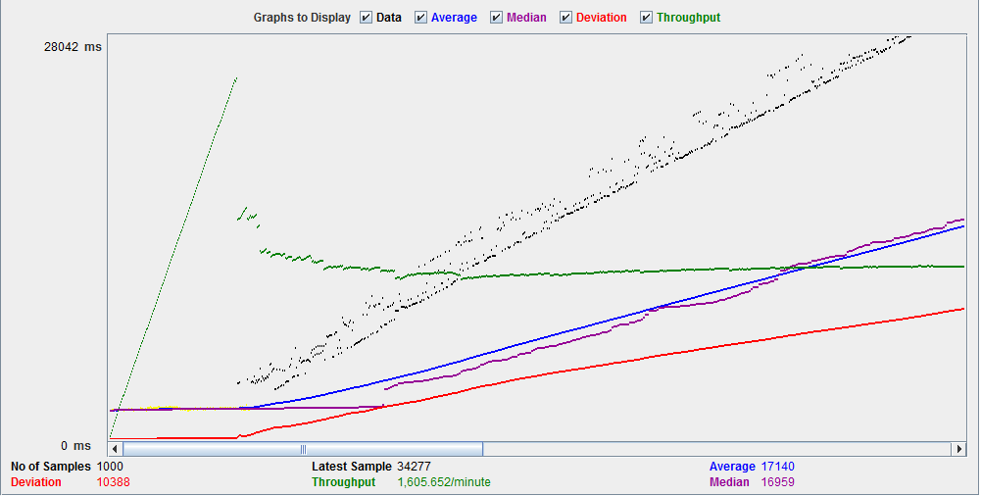

**Result:**

If there are approximately 1000 records in DB and 1000 users are sending request to show list from task table then 15.3% requests are failing as shown is the above graph, red line is showing requests which are getting failed. 1000 requests took around 28.04 seconds to complete with average throughput of 26.8/sec.

**Case 3:**

* Thread Group: 2000 users
* Ramp Up: 1 second
* Loop Count: 1
* No of records in task table: 1022

**Summary Report:**



**Graph Result:**

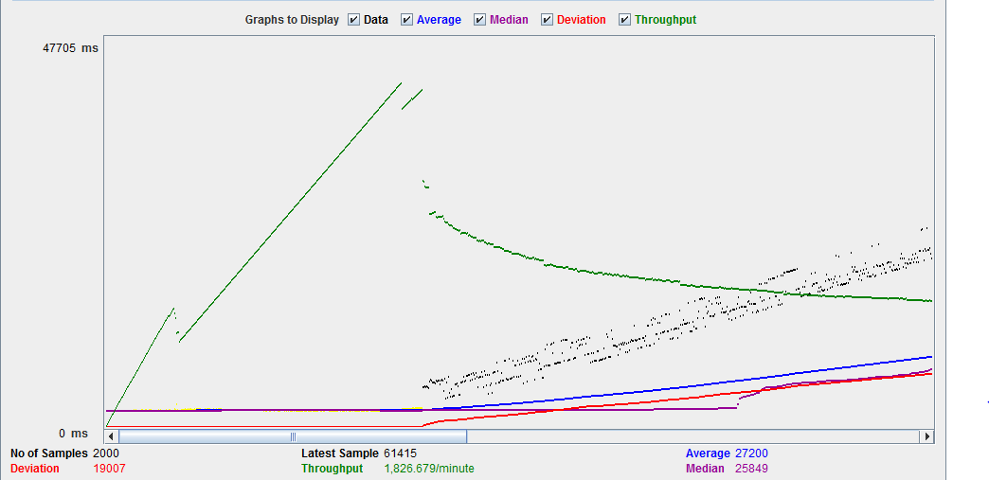

**Result:**

If there are approximately 1000 records in DB and 2000 users are sending request to show list from task table then then 17.3% requests are failing as shown is the above graph, red line is showing requests which are getting failed. 2000 requests took around 47.705 seconds to complete with average throughput of 30.4/sec.